
01 Jan 2016
IDANG AGR
SUPERVISOR’S
HANDBOOK
IDANG AGR
SUPERVISOR’S
HANDBOOK

01 Jan 2016
TABLE OF CONTENTS
Page
CHAPTER 1. PERSONNEL 03
1-1 Human Resources Office
1-2 Supervisory Record-Keeping Responsibilities
1-3 Wear of Military Uniform
1-4 Position Classification
1-5 Manning Documents
1-6 Personnel Actions
SF 52’S
Appointments/Merit Promotions
Voluntary Reassignments
Demotions
Details
Resignations
1-7 Entry/Return to Active Duty
1-8 Restoration Rights
CHAPTER 2. PVA – POSITION VACANCY ANNOUNCEMENT (PVA) 05
2-1 PVA Types
2-2 Announcement Length
2-3 SF 52
CHAPTER 3. HIRING PROCESS 08
3-1 Application
3-2 HRO Review
3-3 Unit Interview
3-4 Selection
3-5 Approval
CHAPTER 4. ORDER TYPES 09
4-1 Initial AGR Tour
4-2 AGR Continuation Tour
4-3 AGR Tour Curtailment
4-4 Occasional AGR Tour
4-5 Occasional AGR Tour Backfill
CHAPTER 5. ORDER REQUEST 10
5-1 ANG 336
CHAPTER 6. ORDER CREATION 14
6-1 ANG 336
6-2 Approval Authority Routing
6-3 AROWS Creation
6-4 AROWS Dissemination
CHAPTER 7. RETIREMENT/SEPARATION 15
7-1 Separation from AGR program
7-2 Retirement from AGR program
CHAPTER 8. WAIVER/EXCEPTION TO POLICY (ETP) PROCESS 16
8-1 20 YEAR TAFMS ETP
8-2 PVA Time Period
CHAPTER 1
PERSONNEL

1-1. General. The Human Resources Officer has been designated to act for The Adjutant General in carrying out the responsibilities of managing the AGR program within the limitations outlined in ANGI 36-101 and by The Adjutant General, Idaho National Guard (IDANG).
1-2. Equal Employment Opportunity (29 CFR part 1614) (Tab J). The Idaho National Guard is committed to seek and correct or eliminate any personnel management policy, procedure, or practice that may result in any disadvantages in employment or deny equality of opportunity to any group or individual on the basis of race, color, religion, gender, age, disability, national origin, or retaliation (as a result of a previous EEO activity).
1-4. The Human Resources Office will:
a. Establish and maintain liaison with the NGB/A1P (Policy) and NGB A1M (Manpower) with regards to AGR issues.
b. Develop and furnish necessary specific personnel policies and procedures to commanders and supervisors of the Idaho National Guard.
c. Ensure that The Adjutant General and staff are informed of NGB policies and regulations pertaining to the administration of the Arkansas National Guard AGR Program.
d. Disseminate routine day-to-day matters through normal command channels for field organizations, and through program managers for support activities. The HRO is the office of record and channel for communications to agencies outside the Idaho National Guard on AGR matters.
e. Establish and maintain AGR Personnel Folders (PF) for Idaho National Guard AGRs. The AGR PF is the official record of Idaho Air National Guard AGR service.
1-4. Personnel Actions.
a. Use of the Standard Form (SF) 52
(1) The Standard Form (SF) 52 "Request for Personnel Action” is used to request position vacancy announcement (PVA) actions. It is the source document used to coordinate requested actions through channels prior to forwarding to HRO. Every effort should be made to ensure that the proper documentation is submitted concurrently with the SF 52 (Military position number, Unit Manning Document authorized rank.). The HRO uses the information on the form to ensure the area of consideration, AFSC, maximum authorized grade, special requirements, and dates of consideration are accurately portrayed in the PVA.
(a) Requesting Official: This person is annotated in the “Action Requested By” block of the SF 52. Normally, the unit commander of the announced position vacancy who approves the appointee from the best qualified candidates. If the Requesting Official is not available due to TDY, deployment, illness etc. for periods in excess of 15 days, the individual delegated with commander authority by the group commander may act as the Requesting Official (written justification must be submitted with the selection package). The Requesting Official submits his/her nomination to the authorizing official for authorization.
(b) Authorizing Official: This person is annotated in the “Action Authorized By” block of the SF 52. This will be the Fighter Wing commander, or delegated representatives, for all units subordinate to and including all Fighter Wing assets. For Joint Forces Headquarters and geographically separated units, the Director of Staff, or delegated representatives, will function as the Authorizing Official. The Authorizing Official will provide the decision of record for these actions.
(c) Details: A detail is the temporary assignment of an employee to a different position for a specified period not to exceed 120 days as outlined in ANGI 36-101, with the employee returning to his regular duties at the end of the detail. Technically, a position is not filled by a detail, as the employee continues to be the incumbent of the position from which detailed. It is agreed that details may be used to meet the temporary needs of the work site when necessary services cannot be obtained by other desirable or practical means. Details may be made under circumstances such as the following: To meet emergencies occasioned by abnormal workload, special projects or studies, change in mission or organization, or unanticipated absences; or pending official assignment, pending description and classification of new position, pending security clearance, and for training purposes (particularly where the training is a part of established or developmental programs).
(2) Every effort will be made to make the requested action effective on the requested date. SF52’s for a PVA will have a required timeline of a minimum of 30 days for announcements where the area of consideration are traditional members or individuals not currently affiliated with the IDANG. SF 52's which are not received with the proper documentation by HRO on or before the due date specified below, will be made effective concurrently with the start of the next reasonable time period. Exceptions will be made only in emergency or critical situations, and will be fully justified in writing.
b. Use of the Air National Guard (ANG) 336
(a) Appointments: Appointment selections will be accomplished by the HRO for The Adjutant General, based upon nominations initiated and forwarded through appropriate channels to the HRO.
(b) Voluntary Reassignments: Voluntary reassignments without a change in grade may be made providing the individual meets the qualification requirements for the new position, the concurrence of both the losing and gaining supervisors is obtained, and compatibility requirements are met
(e) Management Directed Reassignment: Management directed reassignments are used by management to properly align personnel within their organization providing the individual meets the qualification requirements for the new position. Management directed reassignments do not place the employee in a higher or lower graded position than the employee currently holds.
(f) Curtailment for Resignations/Separations/Retirements: Curtailment is the change of the current AGR order end date to match projected resignations, separations, or retirements. These can be either voluntary or involuntary and is the responsibility of the unit commander to communicate this action with HRO. This notification should be made at the earliest possible decision point for the modification of the AGR order.

CHAPTER 2
PVA – POSITION VACANCY ANNOUNCEMENT

2-1. PVA Types
- Concurrent Announcement: This is an announced vacancy, either AGR or Technician, in which the unit provides an opportunity for both AGR and Technicians to pursue career progression. External applicants, i.e. Drill Status Guardsman, other military, civilian, etc., may also apply incumbent on the funding type of the position. If the position is AGR funding, the area of consideration for AGR would be Current On-Board IDANG Technician Only. If an AGR member is selected for a Federal Technician funded position, the unit will be required to complete a Manpower Change Request (MCR) which will be routed for NGB for approval through the MARS system.
- AGR Announcement: This announcement is specifically for an AGR funded position in which a Federal Technician announcement will not be utilized. Area of consideration can be as broad or narrow as desired by the hiring authority.
2-2. Announcement Length. It is the desire of the Assistant Adjutant General, Air to ensure all members of the Idaho Air National Guard have the opportunity to discover and apply for position vacancies. In order to achieve this goal the following criteria has been established:
- All announcements must encompass at least one UTA weekend.
- All PVAs require a 30 calendar day announcement.
- The AAG, Air will consider exception to this policy on a case-by-case basis. Unit/CC must submit a written request to the AAG, Air with justification and receive approval prior to publication of the PVA.
2-3. SF 52. All PVA requests will be made utilizing the SF 52.
An example of a SF 52 for an AGR announcement is included on the next page.
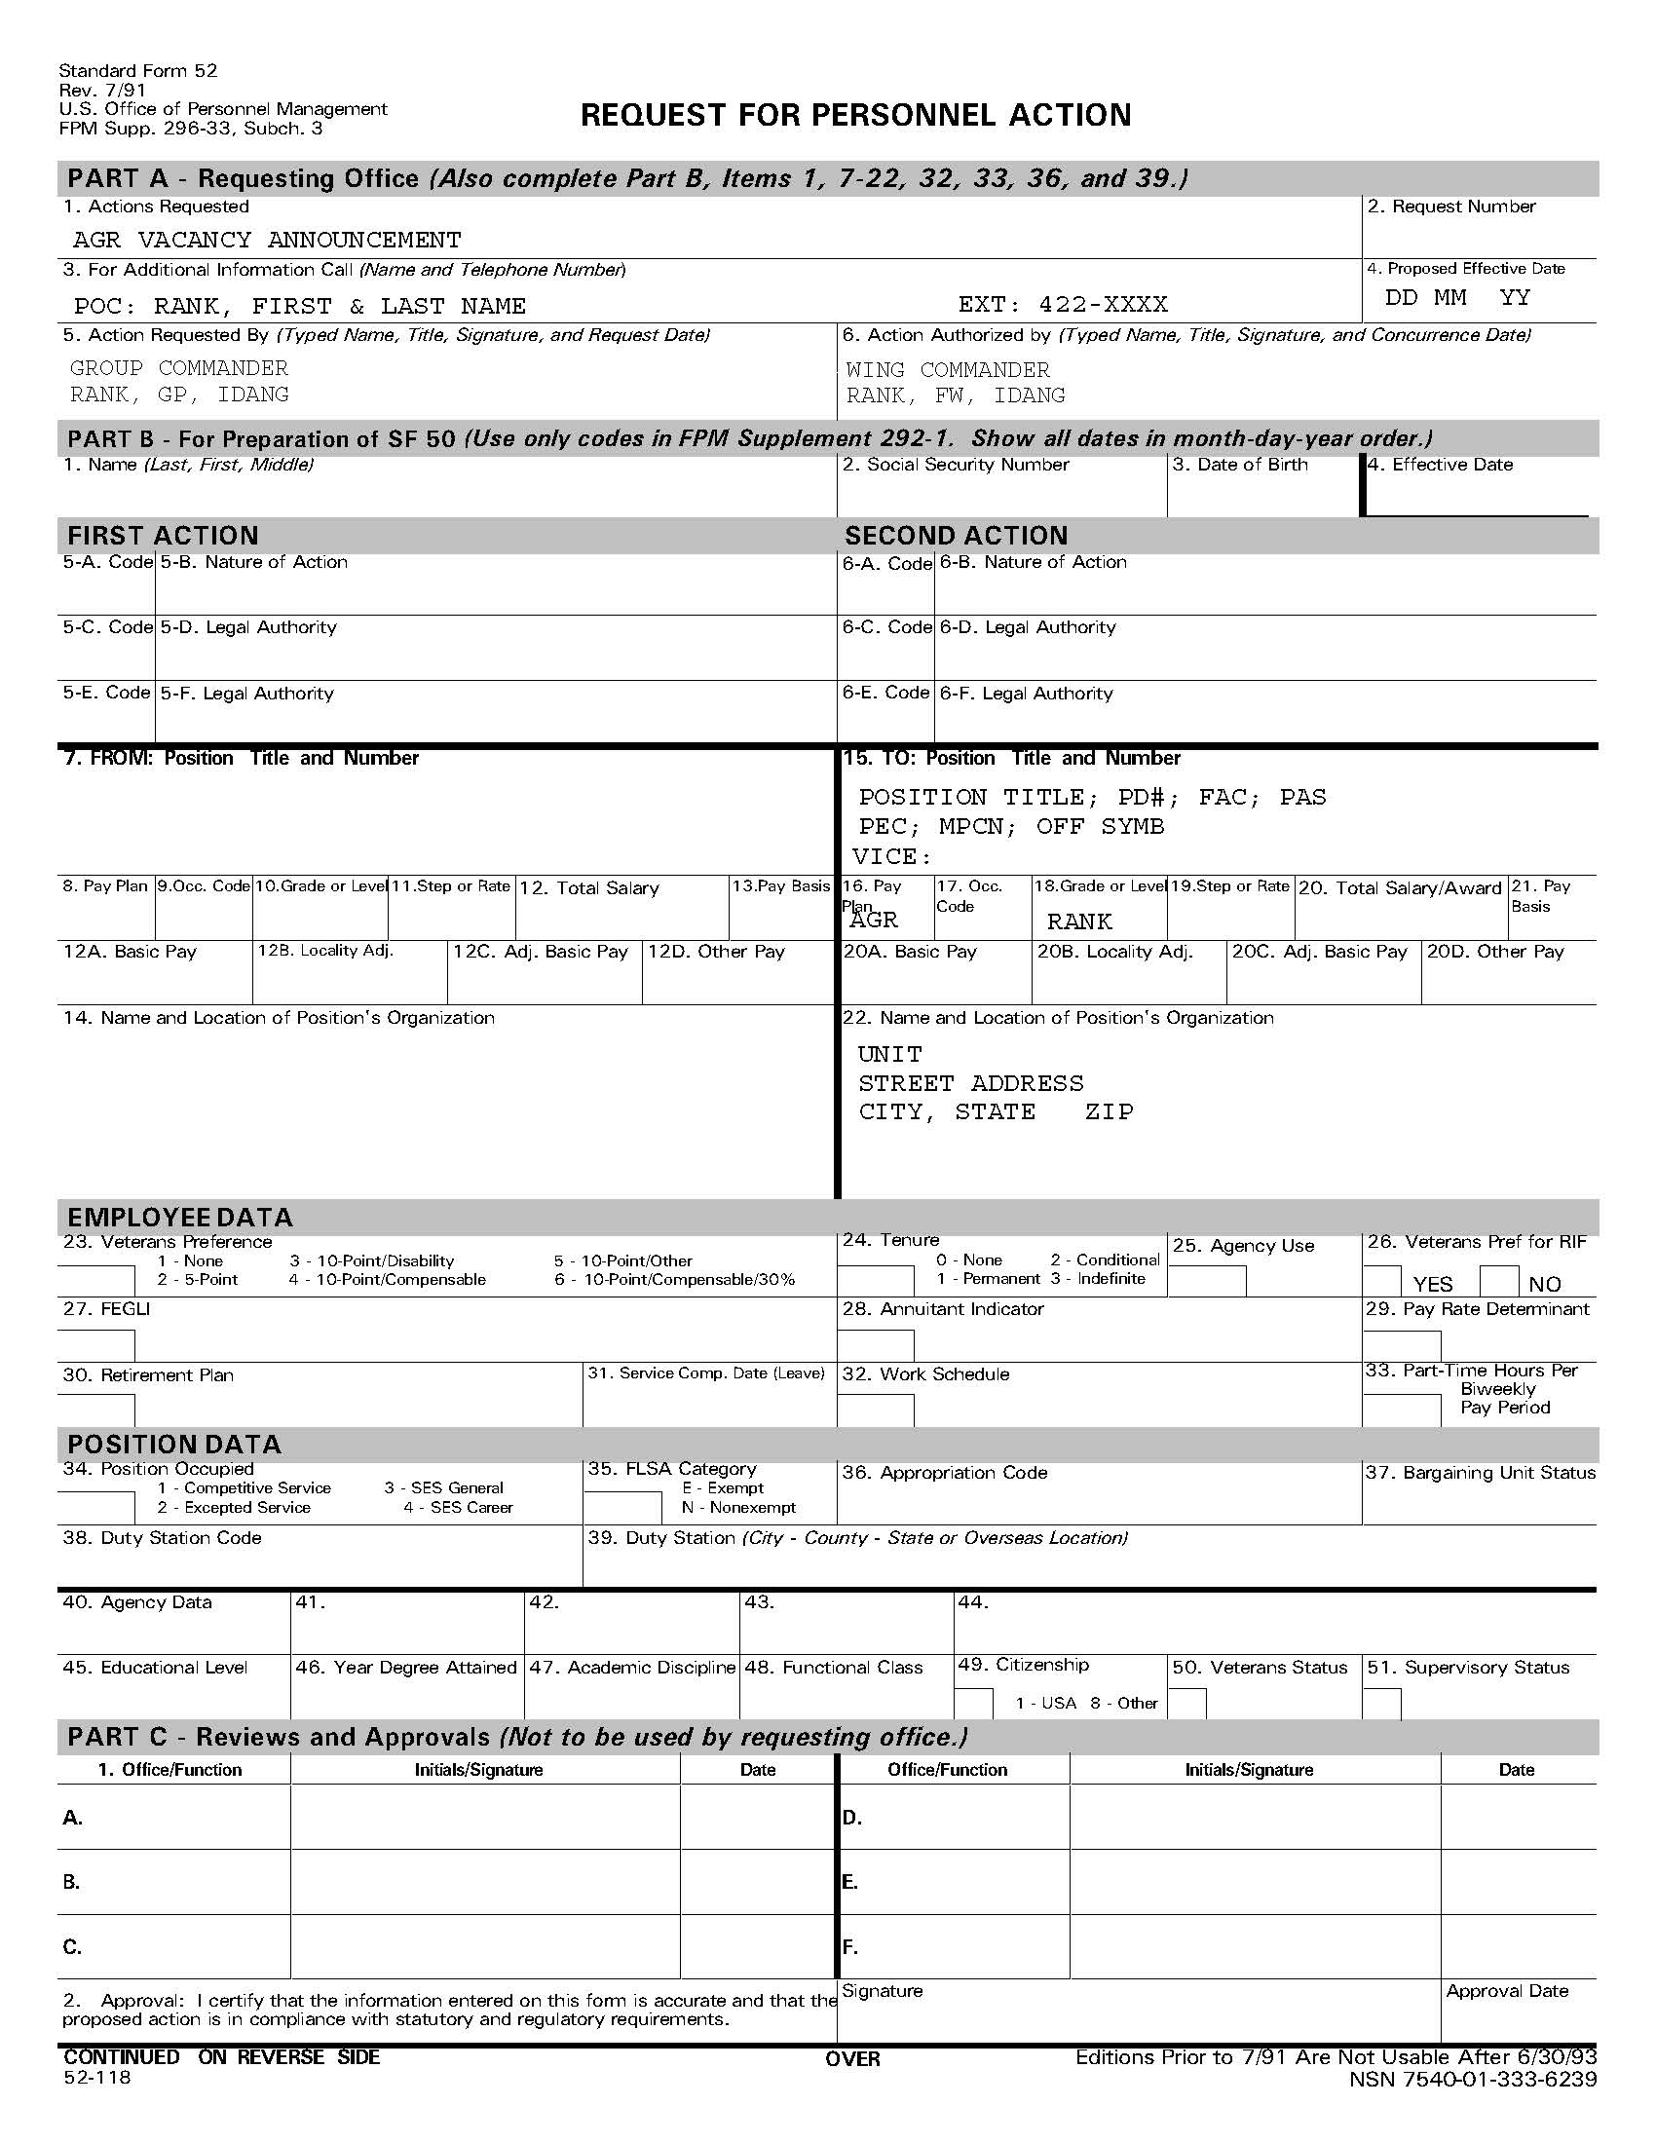
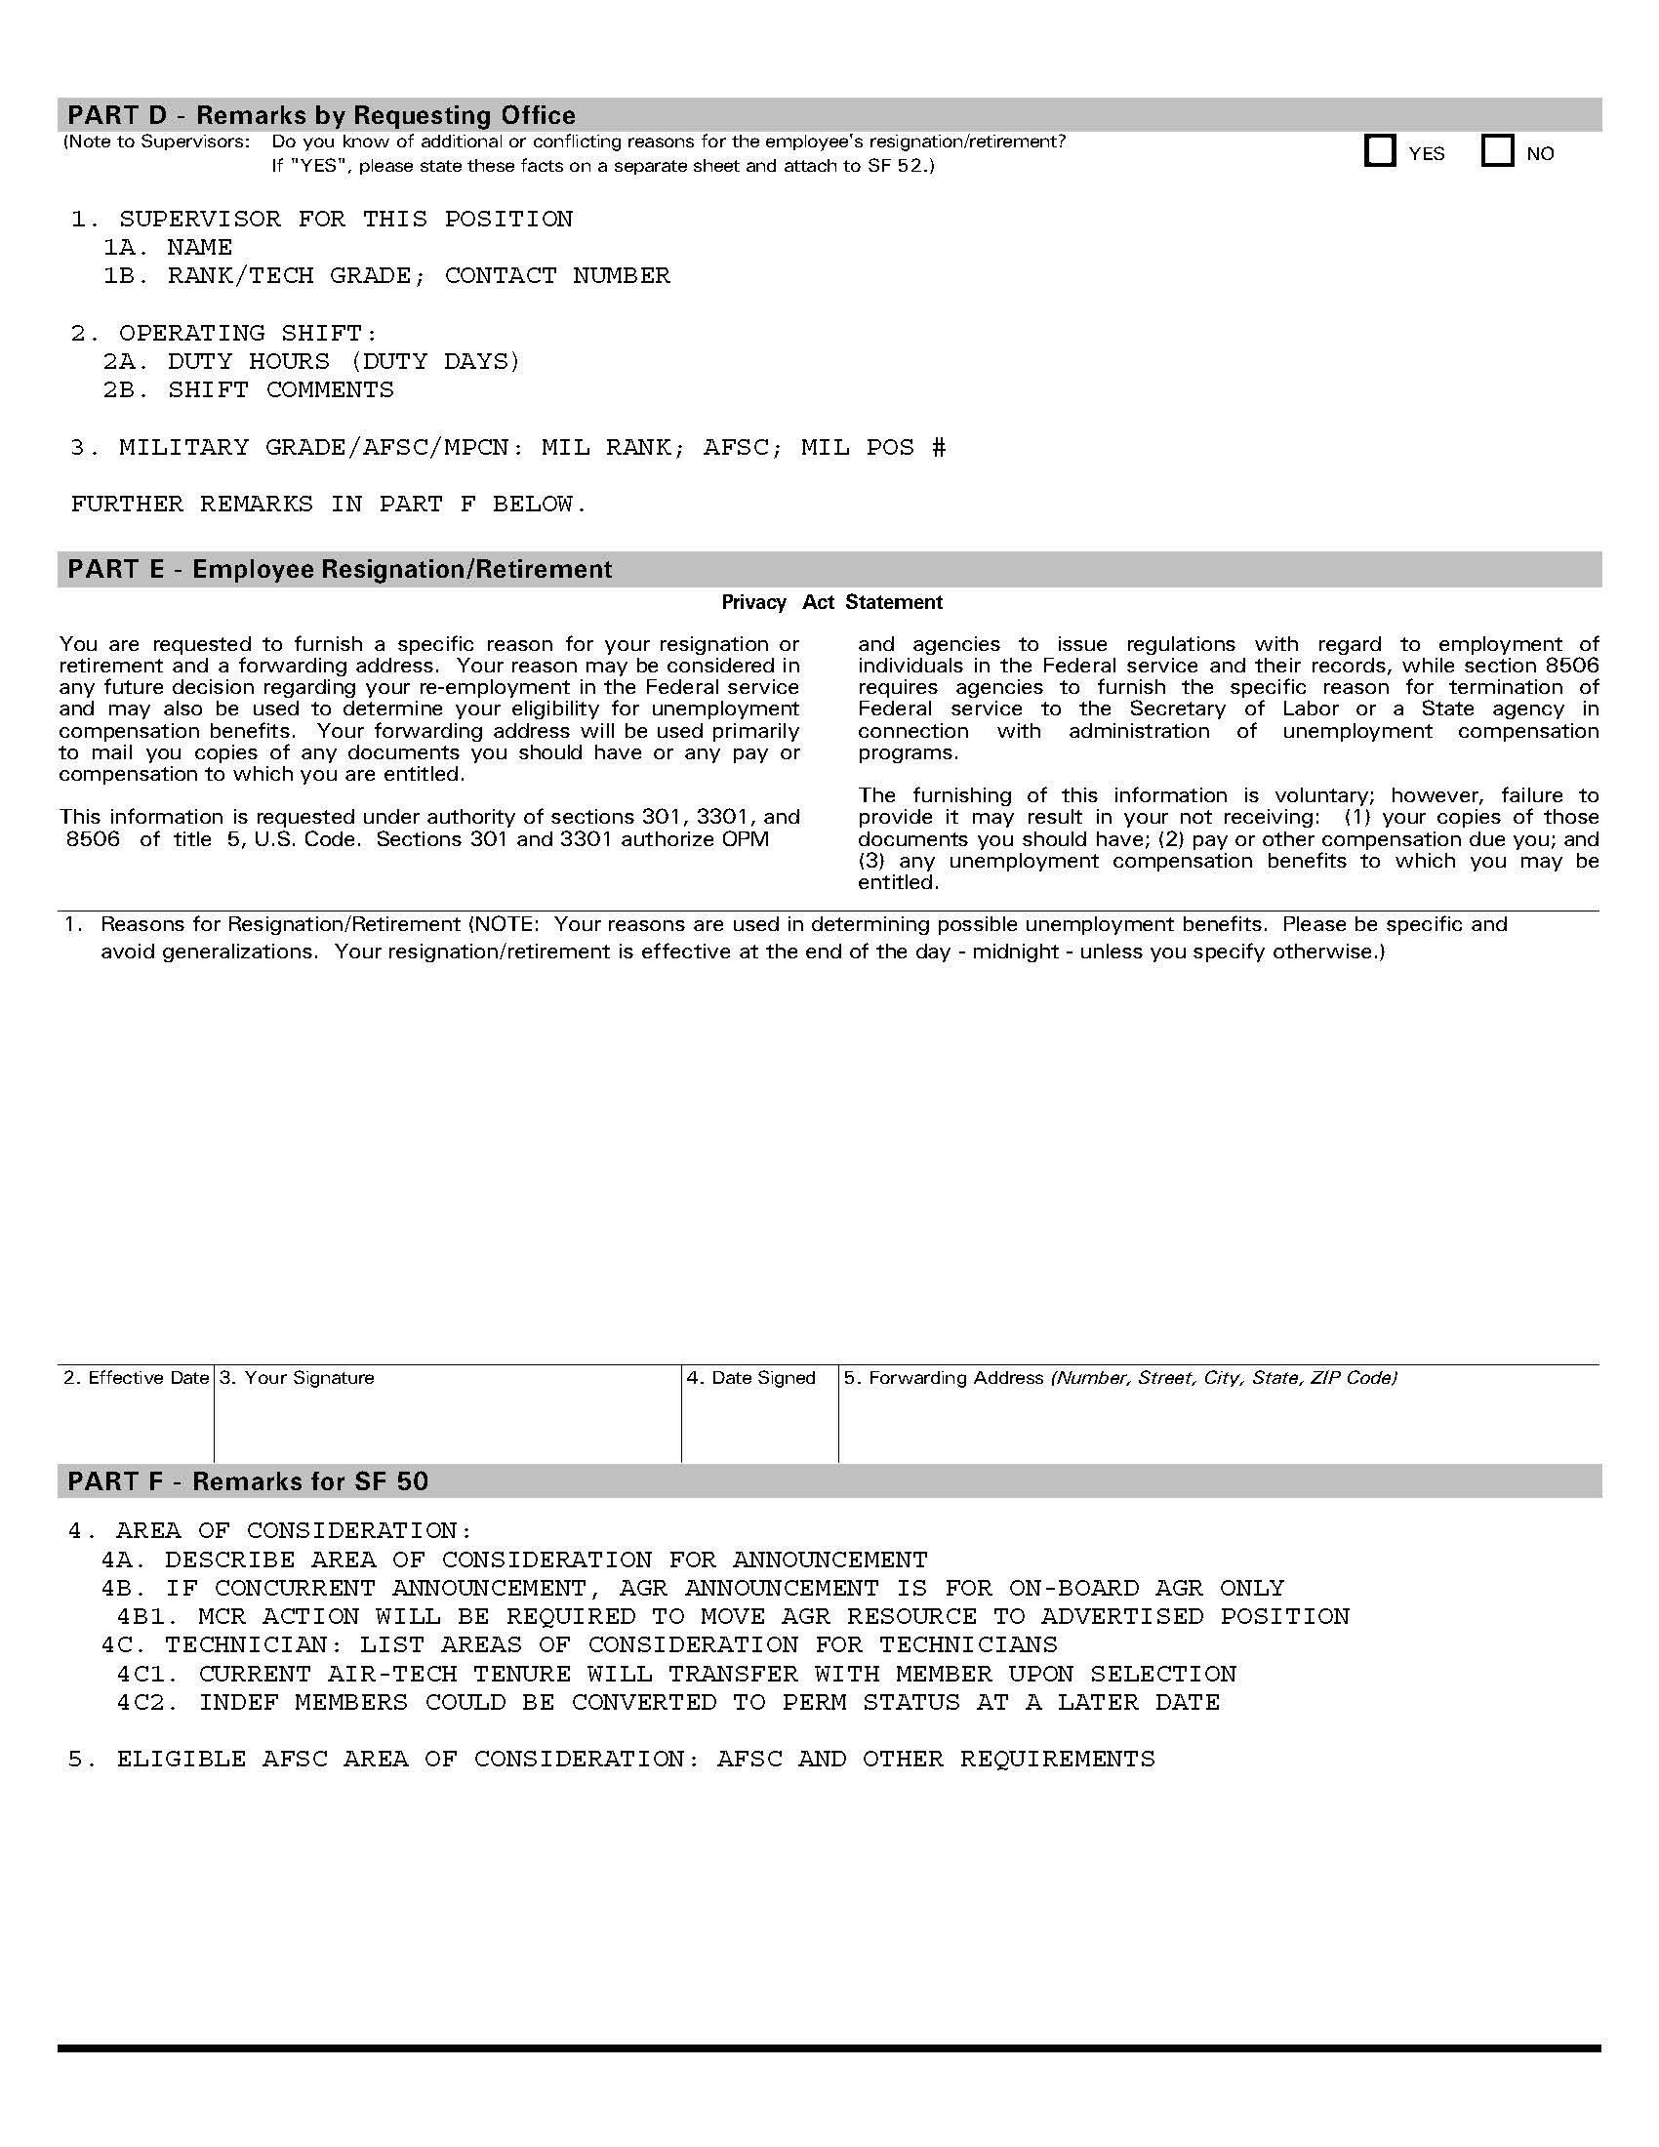
CHAPTER 3
HIRING PROCESS

3-1. Application. All applicants for AGR PVAs will be required to submit at a minimum, a completed NGB 34-1 (application), current PFT results, RIP, PCARS, and a professional resume. All documents must be received by the Air AGR Management Office prior to the advertised closing date and time.
3-2. HRO Review. The Air AGR Manager or designated authority
3-3. Unit Interview. The Human Resources Officer has been designated to act for The Adjutant General in carrying out the responsibilities of managing the AGR program within the limitations described by The Adjutant General and National Guard Bureau.
3-2. Selection. The Idaho National Guard is committed to seek and correct or eliminate any personnel management policy, procedure, or practice that may result in any disadvantages in employment or deny equality of opportunity to any group or individual on the basis of race, color, religion, gender, age, disability, national origin, or retaliation (as a result of a previous EEO activity).
3-3. Approval.
a. Selected applicants must be or become a member of the IDANG as appropriate and assigned to an appropriate unit and maintain the military status as specified on their job description.
b. The Assistant Adjutant General, Air has the authority to approve all selected IDANG AGR applicants. This authority has been delegated to the Joint Force Headquarters, Idaho (JFHQ-ID) Director of Staff (DOS) and the Fighter Wing Commander (FW/CC). The FW/CC may further delegate this action to either the Group or Unit Commanders under their purview.

CHAPTER 4
ORDER TYPES

4-1. Initial AGR Tour. Initial AGR tour orders are probationary. The probationary period will be for a minimum of 3 years and not to exceed six years. If the members ETS is less than the desired tour length, HRO will coordinate with the Force Support Squadron to ensure they perform either a reenlistment or administrative extension.
4-2. AGR Continuation Tour (Career). The AGR Continuation Tour is a Follow-on tour which places the AGR in Career Status. This tour will not exceed six years and will not extend beyond an Airman’s Expiration Term of Service (ETS) or an officer’s Mandatory Separation Date (MSD).
4-3. AGR Continuation Tour (Sanctuary). Members who are in sanctuary or whose AGR Continuation Tour places them in sanctuary will not have their orders extended beyond their 20 yrs TAFMS without receiving an exception to policy from the AAG, Air.
4-4. AGR Continuation Tour (over 20 yrs TAFMS). No AGR member will be extended beyond their 20 yrs TAFMS date without an approved exception to policy from the AAG, Air. All AGR Continuation Tour requests with an approved exception to policy will not exceed two years.
4-5. AGR Tour Curtailment. Curtailment is the change of the current AGR order end date to match projected resignations, separations, or retirements. These can be either voluntary or involuntary and is the responsibility of the unit commander to communicate this action with HRO. This notification should be made at the earliest possible decision point for the modification of the AGR order.
4-6. Occasional AGR Tour. Occasional Tours will be for a minimum of 31 consecutive days but less than 179 days to fulfill validated full-time workload already document on the UMD as full-time requirements. The intent of an occasional tour is to temporarily fill a full-time requirement short term while that requirement is being advertised and hired. Vacant AGR resources will not be filled by continuous occasional tours being served by multiple Airmen or the same Airman. Exceptions to the minimum and maximum tour timeline require approval by NGB/A1P.
4-7. Occasional AGR Tour Backfill. AGRs activated under Title 10 and deployed away from home station for 31 days or more may be backfilled by IDANG members not to exceed the authorized grade of the UMD. The backfill is authorized only for the specific period of the incumbent’s deployment. Copies of CED orders must be provided to HRO to determine backfill inclusive dates.

CHAPTER 5
ORDER REQUEST

5-1. ANG 336. AROWS requires all AGR orders to be requested utilizing the ANG Form 336. In order to be in compliance with this regulation, we will be altering the AGR order process slightly.
The following areas need to be completed for the AGR order:
- DUTY PURPOSE
  - Duty Purpose : Full-Time Duty
  - Gaining Major Command: ACC
  - Phone Comm: Phone number of POC
  - Phone DSN: DSN of POC
  - Exercise/Course Name/Other: N/A
  - POC Name: POC Rank and Full Name
  - POC Email: Self explanatory
- APPLICATION INFORMATION
  - Order Type: Select Active Guard Reserve from the list
  - Request Type: Select appropriate type, i.e. Initial, Modification, Cancellation
      - Note: Modifications are only for data changes such as name, new AGR position, etc. Initial tours are not modified to extend order.
  - AROWS Tracking Number: N/A
  - Order Number: N/A
  - Special Circumstances: Do not use.
  - Include Local Mileage as Only Per Diem: Select Yes or No as appropriate
  - HHG Applicable to this Order? Select Yes or No as appropriate
  - Is the Member Authorized Unaccompanied Baggage Allowance? Select Yes or No as appropriate
- PERSONNEL INFORMATION
  - Member Name: Self explanatory
  - SSN: Self explanatory
  - Depart From: Select appropriate location
  - Return To: Select duty location
  - Address: Member’s Depart From address
  - Address: Member’s Return To address
- DUTY LOCATIONS
  - For Duty With: Unit assigned or to be assigned to as an AGR
  - Unit Name/Duty Location: Unit and either Gowen Field or MHAFB
  - Order Start Date: Self explanatory
  - Order End Date: Self explanatory
  - Address: Unit address
  - Field Condition From: N/A
  - Field Condition To: N/A
  - Actual Expense Allowance: Select appropriate choice from list
  - Technician Exercising The 44-Day Leave Right: Select appropriate choice from list
      - There shouldn’t be an need for multiple Duty Locations. If you believe there is, please contact HRO Air AGR Manager to discuss.
- FUND CITE INFORMATION AND APPROVALS * Do not fill this section out. Except for electronic signatures.
  - Supervisor Signature: Group or Unit Commander signature
  - Approving Official Signature: FW/CC or CV for the Fighter Wing and DOS for JFHQ and GSUs
- CSS NOTES * This section is used for freeform communication from individual completing this form for approval
- SCHOOL * Not used for AGRs
- ACTIVATION *Not used for AGRs
- ACTIVE GUARD RESERVE *This section to be completed by unit
  - Is This in Support of Title 10 Duty for 30 or more consecutive day in support of Active Air Force? Select appropriate response from list
  - Duty Title: Name of duty position
  - UMDG PAS Code: Unit PAS code
  - CAFSC: Member’s Control AFSC
  - DAFSC: AFSC Member will be working in
  - PAFSC: Member’s Primary AFSC
  - TAFMS: Leave blank. HRO and FSS will complete
  - Military Function Account Code: Military position FAC code
  - Military Authorized Grade: Military position authorized grade
  - Military Position Number: Self explanatory
  - Backfill Date Start: Beginning date of CED order
  - Backfill Date End: Ending date of CED order
  - TAFMS Date: Leave blank. HRO and FSS will complete
  - Resource Identification Code: 148 for enlisted and 034 for officer
  - ANG Active Duty Status Code: U for occasional and/or backfill orders. O for all other AGR orders
- PCS DEPENDENT INFORMATION *For Initial AGR tours, all dependent information must be included. This information does not need to be completed for Continuation tours, Modifications, and/or Curtailments.

An example of the ANG 336 is included on the next page.

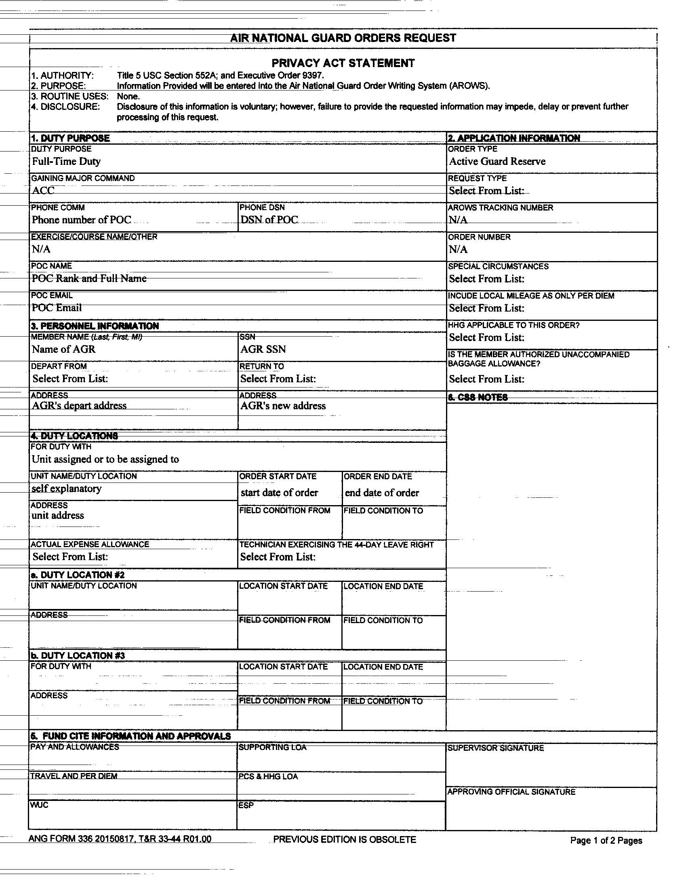
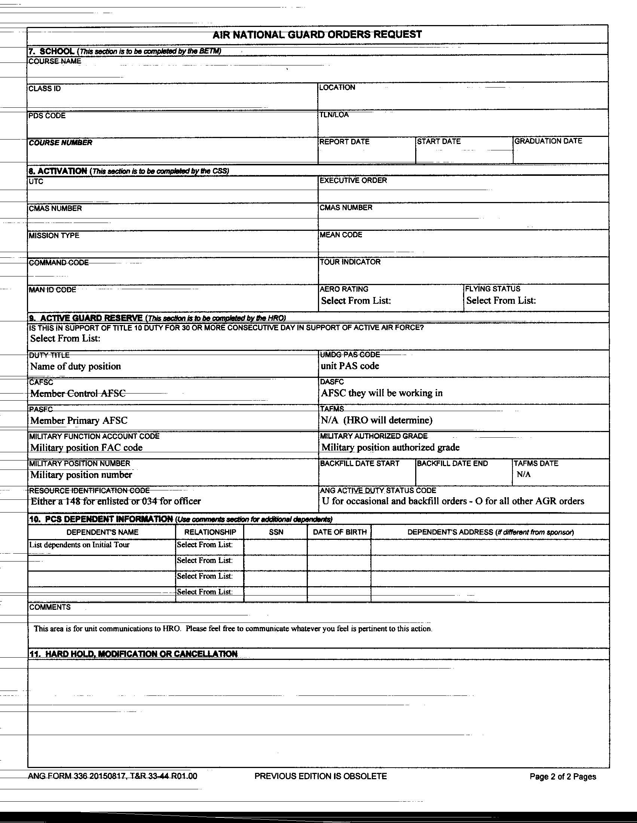
CHAPTER 6
ORDER CREATION

6-1. ANG 336. The Human Resources Officer has been designated to act for The Adjutant General in carrying out the responsibilities of managing the AGR program within the limitations described by The Adjutant General, National Guard Bureau, and the Office of Personnel Management.
6-2. Approval Authority Routing.
a. The Assistant Adjutant General, Air has the authority to approve all selected IDANG AGR applicants. This authority has been delegated to the Joint Force Headquarters, Idaho (JFHQ-ID) Director of Staff (DOS) and the Fighter Wing Commander (FW/CC). The FW/CC may further delegate this action to either the Group or Unit Commanders under their purview.
b. Once the ANG 336 has received the final approval authorities signature, the form will be dropped into the HRO drop box located at xxxxxxxxxxxx.
c. Upon receipt of the ANG 336, the HRO Information Systems Specialist will log the form into the HRO tracker and disseminate to the Air AGR Manager during the HRO daily meeting.
6-3. AROWS Creation.
- The Air AGR Manager will review the ANG 336 for accuracy. Forms that are incomplete or incorrect will be returned to the requesting unit and they will have to make appropriate adjustments and resubmit the corrected ANG 336 through the chain of command for approval.
b. If the ANG 336 is accurate, the Air AGR Manager will submit an AGR Medical Clearance form to the 124 MDG to medically clear the new AGR member for Initial, Occasional, and Backfill tours. All other types of AGR orders are created for current AGR members and will not require medical clearance.
b. The order will then be created within the AROWS system according the AROWS User’s Manual, 06.4 – AGR Orders Specialist and forward through the appropriate AROWS authorization chain.
6-4. AROWS Dissemination.
a. All approved orders will be disseminated to the AGR member, their unit supervisor, unit manpower representative, FSS representative, CPTF representative, and Retention Office Manager as appropriate.
b. A hard copy of the order will be placed into the AGR member’s UPRG.
CHAPTER 7
RETIREMENT / SEPARATION

7-1. Separation from AGR Program.
a. Any current AGR member is authorized to submit a letter requesting separation from the AGR program through their chain of command. The letter must include sufficient justification as to why they desire to separate. The Fighter Wing Commander is the final approval for all units within their purview. The Director of Staff is the final approving authority for all JFHQ-ID and GSU units.
b. Upon approval of separation, the losing unit must submit an ANG 336 through the approval chain as outlined in paragraph 6.2. Once HRO has received this document, the Air AGR Manager will modify the current order to curtail the order to the approved date.
b. The order will then be disseminated as outlined in paragraph 6.4.
7-2. Retirement from AGR Program. A copy of the current IDANG Retirement Handbook can be located at http://inghro.idaho.gov/hr/pocs/agr-air/airagr.htm. Use this guide to complete your retirement process.

CHAPTER 8
WAIVER/EXCEPTION TO POLICY (ETP) PROCESS

8-1. 20 Year Total Active Federal Military Service (TAFMS) ETP. Continuation beyond 20 years will be considered on an individual basis and may be recommended by JFHQ-ID/DS or the Wing Commander. Authorization for subsequent AGR tours will be based on mission requirements, past performance, and current/future authorized force structure. Requests for extension will be for any time period not to exceed three years unless the member is participating in an approved special/bonus program. Participants in special/bonus programs will be extended in accordance with program requirements. Commanders will forward requests to extend AGR personnel past the 20-year point through their respective chain-of-command to the Assistant Adjutant General, Air, no later than nine months prior to the 20-year TAFMS date. Those approved for extension beyond the 20-year point will require approval for subsequent extensions, and those requests also must be submitted no later than nine months prior to the expiration of the current tour.
8-2. PVA Time Period ETP. All Projected Vacancy Announcements (PVA) will be advertised for a minimum of 30 calendar days and stay open over a drill weekend. Any exceptions to these timelines require approval of the Assistant Adjutant General, Air.
An example of the 20 Yr TAFMS ETP letter is included on the next page.
